ZOMATO DATASET ANALYSIS

Intern Name: Harshitha S M
Organization: Alfido Tech
Domain: Data Science Internship

Executive Summary
This project analyzes the Zomato restaurant dataset to identify trends in restaurant ratings, cuisines, pricing, and online delivery services. The objective is to derive meaningful business insights using data analysis and visualization techniques.

Objective
1.Analyze restaurant ratings.
2.Identify popular cuisines.
3.Study the impact of online delivery.
4.Understand restaurant distribution.

Tools Used
1.Python
2.Pandas
3.NumPy
4.Matplotlib
5.Seaborn
6.Jupyter Notebook
7.Data Cleaning
8.Removed duplicate records.
9.Handled missing values.
10.Converted ratings into numeric format.
11.Checked data consistency.

Analysis Performed
1. Rating Analysis:
Most restaurants received ratings between 3.5 and 4.5.
2. Cuisine Analysis:
North Indian, Chinese, and Fast Food were the most common cuisines.
3. Cost Analysis:
Average cost for two people was found to be moderate across most restaurants.
4. Online Delivery:
Restaurants offering online delivery generally attracted more customer engagement.

Visualizations
1.Ratings Distribution Histogram
2.Top Cuisines Bar Chart
3.Restaurant Count by City
4.Online Delivery Analysis
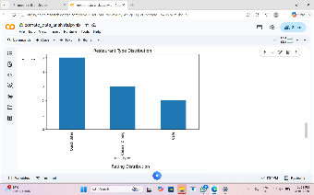
5.Cost Distribution Chart
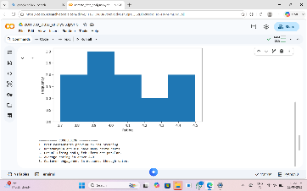
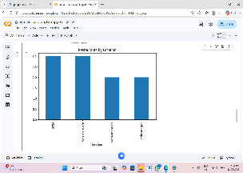
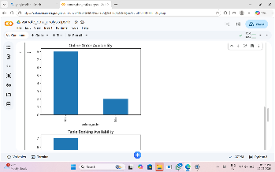

Key Findings
1. Most restaurants maintain ratings above 3.5.
2. North Indian cuisine dominates the dataset.
3. Online delivery increases customer reach.
4. Restaurant density is higher in metropolitan areas.
5. Mid-range pricing attracts the largest customer base.

Conclusion
The Zomato dataset provides valuable insights into restaurant performance and customer preferences. Businesses can use these findings to improve services and increase customer satisfaction.

GitHub Repository:
GitHub Link: https://github.com/harshithagowda9867-source/Alfido-tech-intership

Notebook Link:
Colab/Jupyter Link: _https://colab.research.google.com/drive/1Fs2FGv6URVeJe9aJdyGzh8qFCQGcDjbc#scrollTo=HVM-mDbg3ojj&line=1&uniqifier=1

